What is PostgreSQL?
PostgreSQL is a free open-source database system that supports both relational (SQL) and non-relational (JSON) queries.
PostgreSQL is a back-end database for dynamic websites and web applications.
PostgreSQL supports the most important programming languages:
- Python
- Java
- C/C++
- C#
- Node.js
- Go
- Ruby
- Perl
- Tcl

Download PostgreSQL
https://www.enterprisedb.com/downloads/postgres-postgresql-downloads
install next next =>

PostgreSQL - pgAdmin4

Connect to the Database
In the previous chapter we learned how to connect to the database using the SQL Shell (psql) application, which is a command-based application that allows us to interact with the PostgreSQL database.
There is another application that comes built-in with the PostgreSQL installation, the pgAdmin 4 application, which also offers to interact with the database, but in a more user-friendly way.
Let us take a look and see how it works.
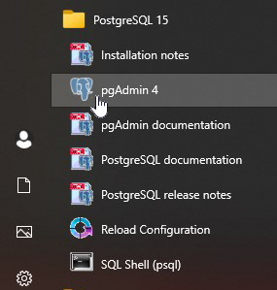

pgAdmin4
Once you are inside the program, try to perform a simple SQL query.
To do that we have to navigate to the database.
Start by opening the [Servers] option in the menu on the left:

Connect to Server
Now you need to enter the password that you created when you installed PostgreSQL, my password is 12345678:
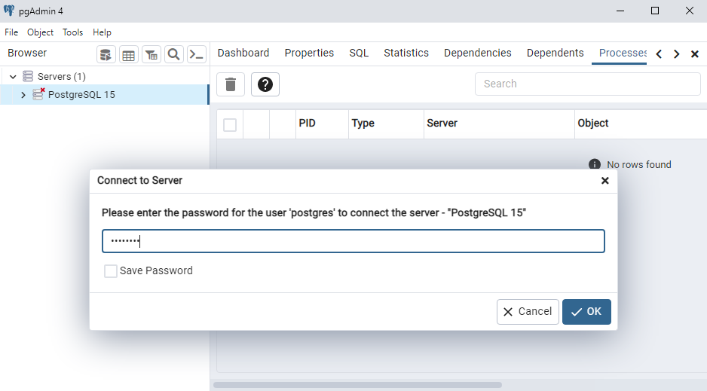

Find Database

Click on the [Database] option on in the menu on the left:
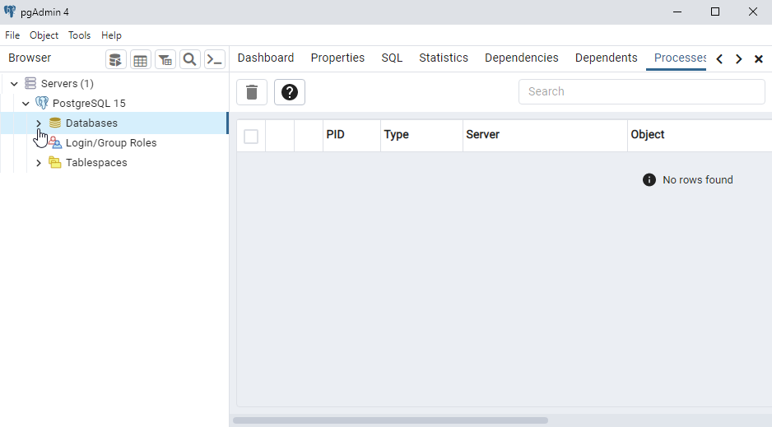

Open Query Tool
You should find a database named postgres, right-click it choose the "Query Tool":
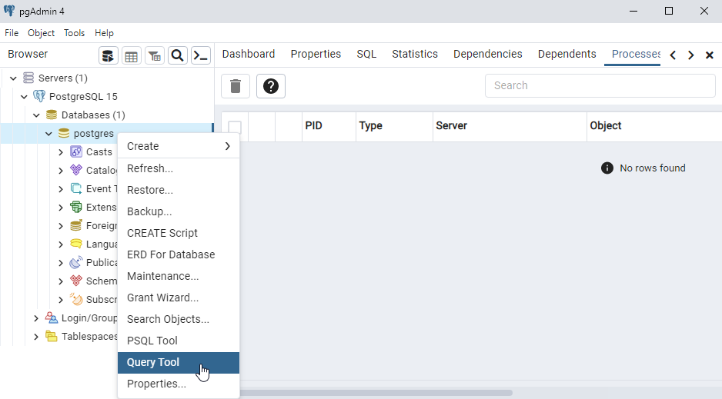

Query Tool
In the Query Tool we can start executing SQL statements.
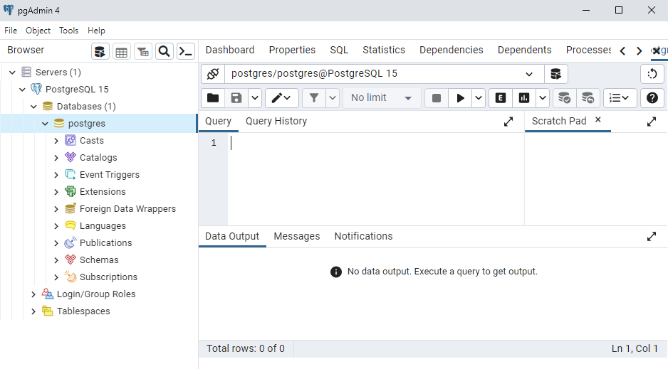

Write SQL Statements
Our database is empty, so we cannot query any tables yet, but we can check the version with this SQL statement:

PostgreSQL Create Table

Simple table create
CREATE TABLE users ( id BIGINT GENERATED ALWAYS AS IDENTITY PRIMARY KEY, username VARCHAR(50) NOT NULL, email VARCHAR(100) UNIQUE NOT NULL );

Table create with foregn key

CREATE TABLE employees ( employee_id INT GENERATED ALWAYS AS IDENTITY PRIMARY KEY, first_name VARCHAR(50) NOT NULL, last_name VARCHAR(50) NOT NULL, department_id INT, -- Explicitly defining the foreign key constraint CONSTRAINT fk_department FOREIGN KEY (department_id) REFERENCES departments (department_id) ON DELETE SET NULL );

INSERT INTO users (username, email) VALUES ('johndoe', 'john@example.com');

SELECT * FROM cars;
ALTER TABLE cars ADD color VARCHAR(255);
ALTER TABLE cars DROP COLUMN color;

UPDATE cars SET color = 'red' WHERE brand = 'Volvo';
DELETE FROM cars WHERE brand = 'Volvo';
DROP TABLE cars;

Node + PostgreSql

